FOR ENGLISH PLEASE SEE BELOW

PERSBERICHT

SMART Project Space
Arie Biemondstraat 105-111
NL- 1054 PD Amsterdam

Matthieu Laurette presents:
ARTISTS’ BIOPIC CINEMA featuring Rembrandt, Vermeer, Kahlo, Pollock, Warhol and others

Openingsreceptie 1 november 2008, 19.00 uur. Persvoorstelling: 18.00 uur. Tentoonstelling t/m 20 december 2008

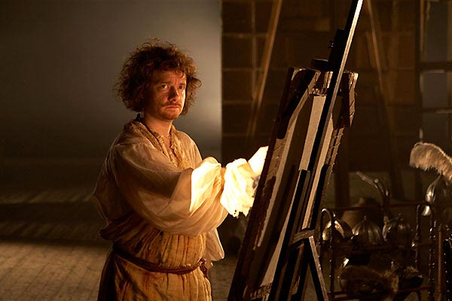
Nightwatching, 2007

Matthieu Laurette (Frankrijk, 1970) onderzoekt de relatie tussen kunst, spektakel, media en economie. In de tentoonstelling ‘Matthieu Laurette presents ARTISTS’ BIOPIC CINEMA - featuring Van Gogh, Kahlo, Picasso, Pollock, Warhol...’ heeft hij het iconische beeld van de kunstenaar als temperamentvol en vrijgevochten genie, een beeld nog steeds een grote rol speelt in de westerse cultuur, als uitgangspunt genomen. De tentoonstellingszalen van SMART Project Space worden ingericht als mini-bioscoopzalen waar circa 18 speelfilms van verschillende regisseurs vertoond worden. Alle films zijn gefictionaliseerde verhalen over het leven van bekende kunstenaars zoals Andy Warhol, Rembrandt, Vincent van Gogh, Francis Bacon en Salvador Dali. Zo kan de bezoeker zelf een beeld te vormen van de wijzen waarop de speelfilmindustrie de mythologisering van het leven van de kunstenaar cultiveert en in stand houdt.

Matthieu Laurette (1970, Villeneuve St Georges, Frankrijk) woont en werkt in Amsterdam. Recente projecten zijn onder meer I Am An Artist, Gaudel de Stampa, Parijs (2008) [Solo]; Beyond Paradise, Stedelijk Museum Bureau Amsterdam, Amsterdam (2008); EXHIBITION NON STOP: A One Year Solo Show, Blow de la Barra, Londen (2008) [Solo]; Real Estate, Deweer Art Gallery, Otegem (2007) [Solo]; MediaScope: An Evening With Matthieu Laurette, MoMA, New York (2007); Let's Make Lots of Money, Blow de la Barra, Londen (2006) [Solo]; Notre Histoire, Palais de Tokyo, Parijs (2006); Video: An Art, A History, 1965-2005, New Media Collection, Centre Pompidou, Miami Art Central, Miami (2006).

Noot voor de redactie
Voor meer informatie en beeldmateriaal kunt u contact opnemen met de afdeling Pers en Communicatie
telefoon +31 20 427 59 51 of press@smartprojectspace.net
Bij publicatie graag vermelden: www.smartprojectspace.net

Press release

SMART Project Space
Arie Biemondstraat 105-111
NL- 1054 PD Amsterdam

Upcoming exhibition
Matthieu Laurette presents: ARTISTS’ BIOPIC CINEMA featuring Rembrandt, Vermeer, Kahlo, Pollock, Warhol and others

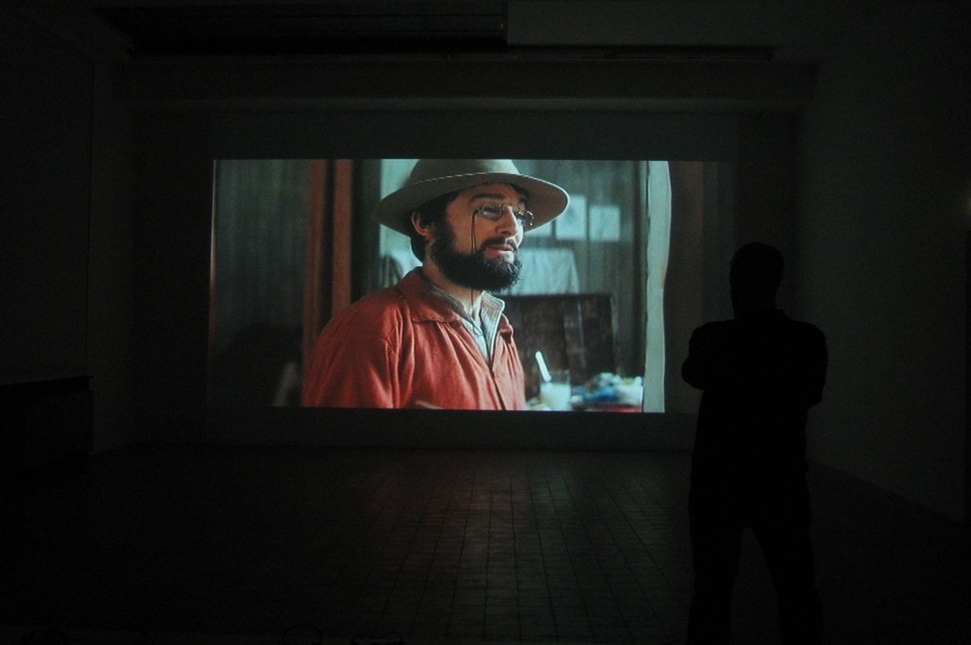
Opening reception: Saturday 1 November, 19.00 hrs Press preview: 18.00 hrs. Exhibition: 1 November - 20 December 2008

SPS presents a solo exhibition of new work by French artist Matthieu Laurette. Laurette established himself in the 1990’s with his exploration of the relationships between art, spectacle, media and economy using a variety of media, from TV and video to installation and public interventions.

For the exhibition ARTISTS’ BIOPIC CINEMA, the allegory of the artist as a temperamental genius and free from the constraints of society is played out. By transforming all 6 gallery spaces into mini cinemas, Laurette presents the mythologised life of the artist by screening 18 specifically chosen feature films daily.
The films offer an insight into the fictionalized lives of famous artists such as Andy Warhol, Rembrandt, Vincent van Gogh, Frida Kahlo, Francis Bacon and Salvador Dali to name but a few. Visitors are given an excellent opportunity to observe ways in which the film industry cultivates, feeds and perpetuates the myth of the artist-genius.

"I never decided "Oh yes great, tomorrow let's work with media and TV or legal fields! They are surrounding us, we are part of it, so - it seems clear to me that I have to deal with them. I'm just trying to find the best "spots" to develop activities that often interact with different audiences. I'm trying to "hack" or "hijack" contexts, media, audiences, budgets etc., to produce dis-junctures. Dis-junctures often generate their own tools, which one can in turn appropriate and use." Matthieu Laurette.

Matthieu Laurette (born 1970, Villeneuve St Georges, France) lives and works in Amsterdam. Recent selected exhibitions and projects include I Am An Artist, Gaudel de Stampa, Paris (2008) [Solo]; Beyond Paradise, Stedelijk Museum Bureau Amsterdam, Amsterdam (2008); EXHIBITION NON STOP: A One Year Solo Show, Blow de la Barra, London (2008) [Solo]; Real Estate, Deweer Art Gallery, Otegem (2007) [Solo]; MediaScope: An Evening With Matthieu Laurette, MoMA, New York (2007); Let's Make Lots of Money, Blow de la Barra, London (2006) [Solo]; Notre Histoire, Palais de Tokyo, Paris (2006); Video: An Art, A History, 1965-2005, New Media Collection, Centre Pompidou, Miami Art Central, Miami (2006).

Editorial note
For more information video and photo material, please contact the press and communication department
telephone +31 20 427 59 51 or press@smartprojectspace.net
By publication, please mention: www.smartprojectspace.net

